**Report**

The goal of this project was to develop a system that accurately detected pedestrians and vehicles from an image and estimated the distance to these objects. I made use of object detection through YOLO, and implemented two approaches to stereo vision: dense and sparse. I consider the dense approach my primary solution, with sparse being an alternative approach to reach the same conclusion.

**My Solution – Design Choices**

**Histogram Equalisation**: Illumination in the provided dataset was an issue, so an attempt to reduce this before calculating the disparity map was made. I used CLAHE to do so – an advanced histogram equalisation method.

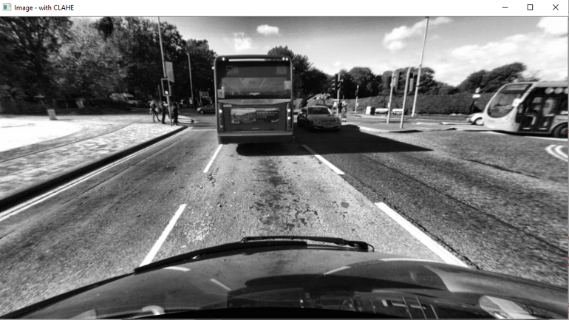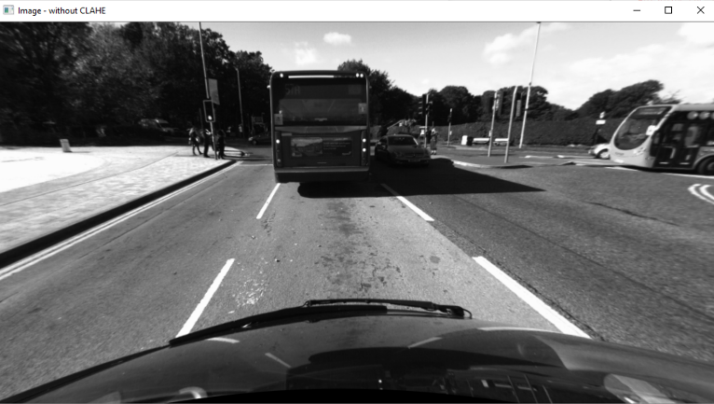The contrast of the CLAHE image is improved, making the image sharper and darker regions more visible.

Fig 1a – Image with equalisation

Fig 1b. Image with CLAHE applied

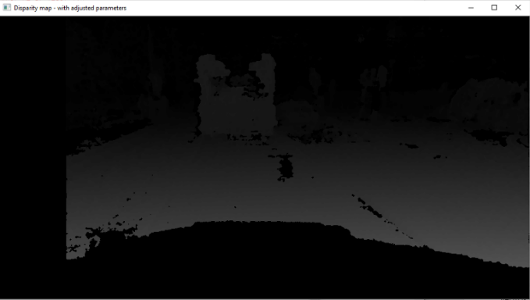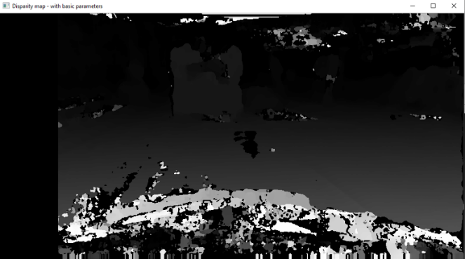**Stereo_SGBM parameters**: Adjusting the input parameters for the SBGM object was critical in producing an accurate, but somewhat noiseless, disparity map. Many parameters allowed for the removal of later functions calls – e.g. filterSpeckles was integrated into the object itself through several of its founding arguments.

Fig 2b. Adjustments to parameters

Fig 2a. No adjustments to parameters

**Calculating distance**: For each object a Gaussian kernel was generated (based on the size of the object detected). A matrix of disparities was then taken from the image of the same size, centred on the central pixel location. The convolution of this matrix with the kernel is then performed, from which distance is calculated.

Much testing showed that altering the size of the kernel was critical to determine correct distances. Further objects would display poor distances or the time to calculate would significantly increase.

Despite the similarities in the examples below, I found the **Gaussian kernel** approach to have the best consistency to accuracy ratio. Other variants typically had decent results, however, would produce inconsistent or inaccurate values far more regularly.

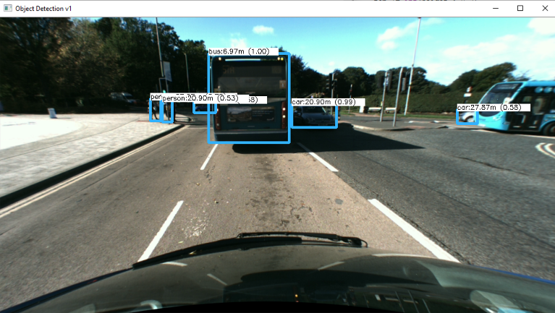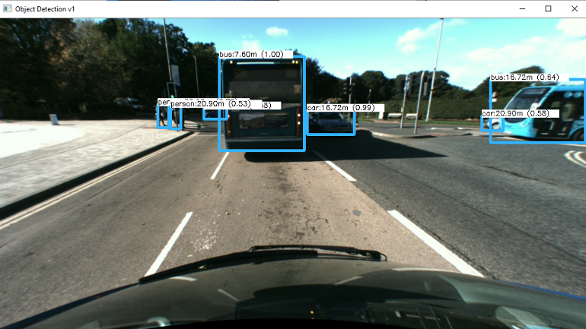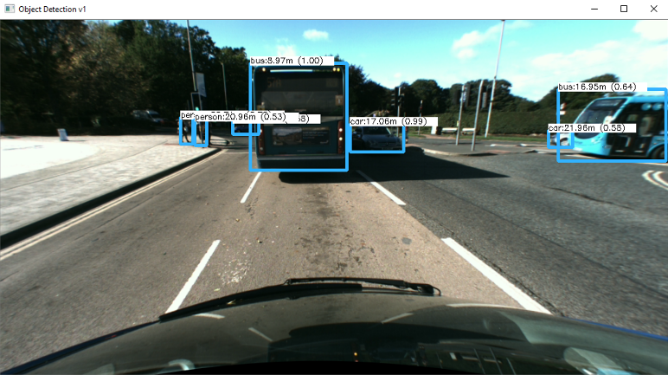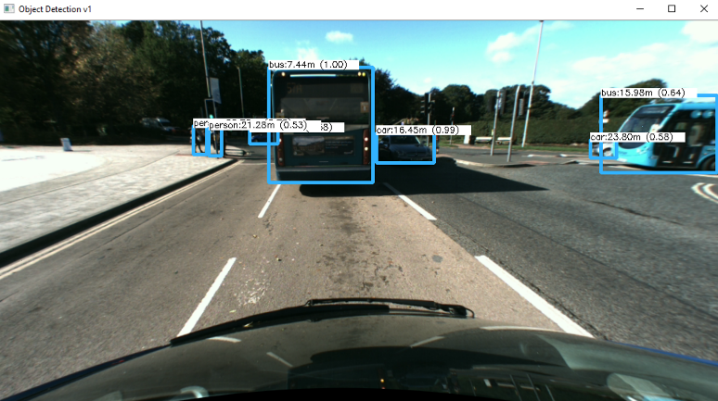

Fig 3b. Central pixel selected

Fig 3b. Median filter applied

Fig 3b. Gaussian Kernel

Fig 3a. Averaging the disparities

Fig 3b. Gaussian kernel

Fig 3c. Median filter

Fig 3d. Central point

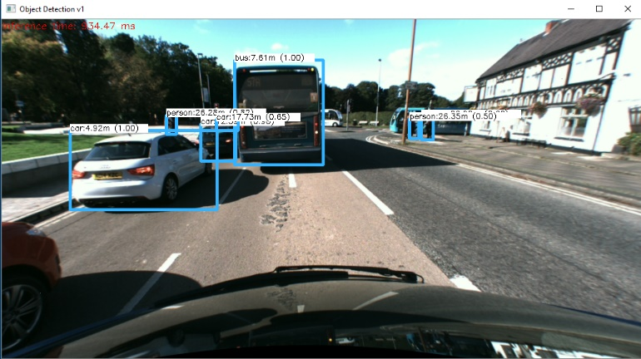**YOLO edge detecting**: In an attempt to detect more objects (primarily pedestrians) several denoising & edge enhancements techniques were applied to the image. All denoising filters with edge enhancement techniques tested proved to detect less objects – primarily due to the loss of detail in the image (through noise reduction). However, the use of a simple kernel and 2D filtering on the image demonstrated an increase in useful objects detected!

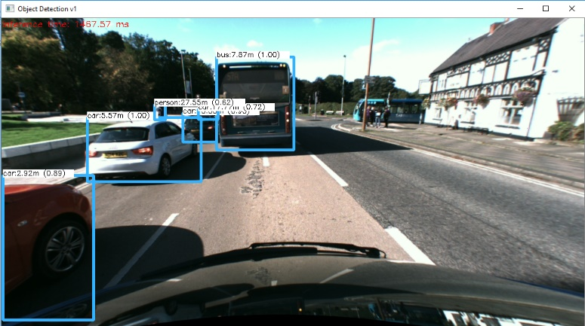

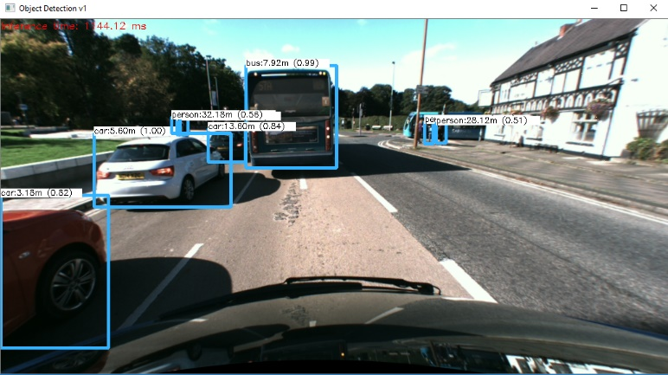

Fig 4b. Regular image (2)

Fig 4a. Regular image (1)

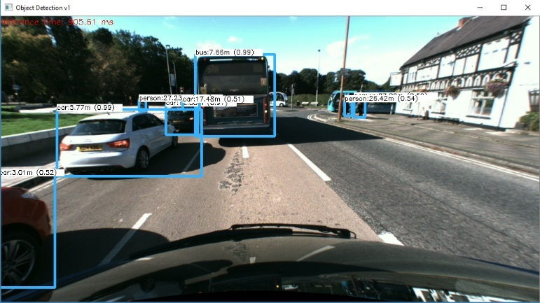

Fig 4d. Edge enhanced image (2)

Fig 4c. Edge enhanced image (1)

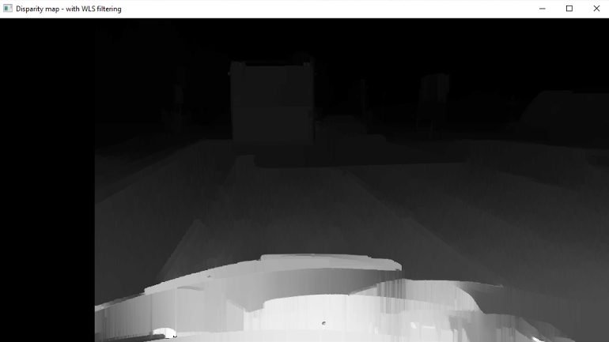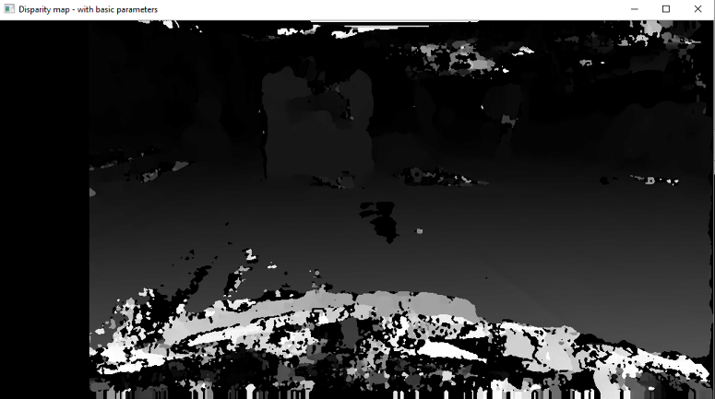**Weighted least square (WLS) filter**: The use of the WLS filter along with the use of a left-right-consistency based confidence was attempted to improve the quality of the resulting disparity map (through ‘filling in the holes’). The hope here was a smoother, less noisy disparity map would subsequently improve distance calculations. However, I found that the removal of noise also removed much useful information from the map, with this causing a decrease in the accuracy of many object distances. Hence I did not integrate WLS into my final solution.

Fig 5b. WLS filtered disparity map

Fig 5a. Normal disparity map

**My Solution – Analysis of correctness**

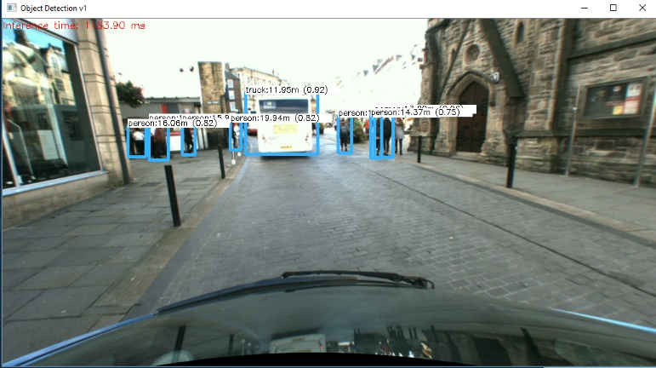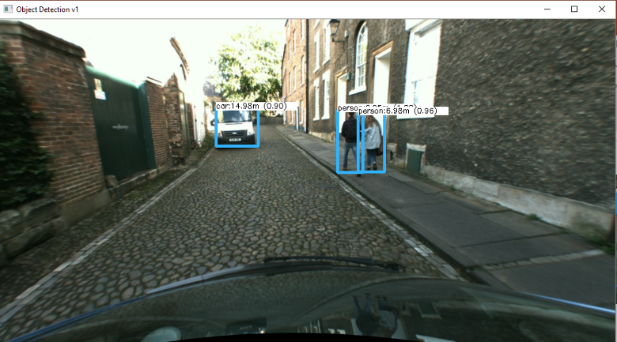The below images are a random selection of images from the test data. They demonstrate below show the solution identifies the required objects within the scene (pedestrians and vehicles), draws boxes around them and displays a corresponding distance with each box

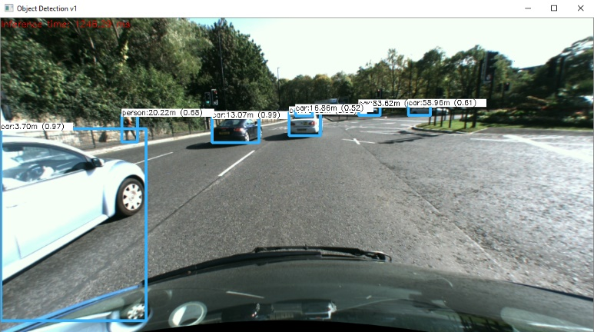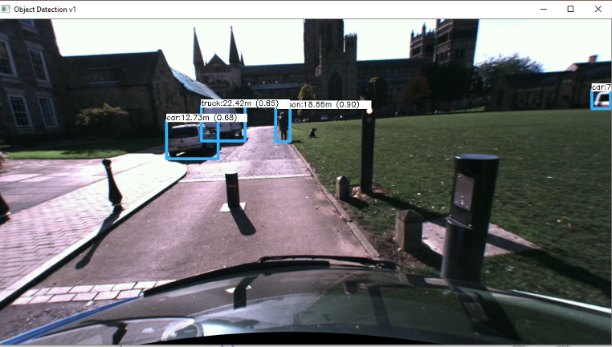

Fig 6b.

Fig 6a.

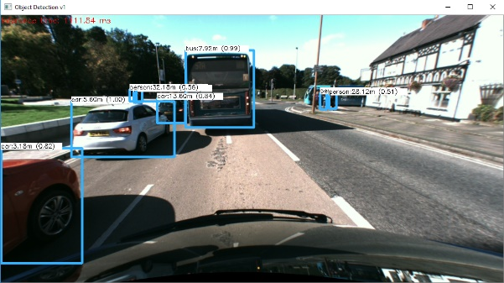

Fig 6e.

Fig 6d.

Fig 6c.

**Conclusion**:

The solution detects objects well, but often fails to detect a pedestrian – both fig. 6a and fig 6e show this. As further objects typically produce inaccurate distances, such as the 89m visible in fig. 6d.

However, the solution deals well with crowded regions (see fig. 6a) and objects with noise (e.g. bus in fig. 6a, car in fig. 6d)

Proof of correctness

In order to measure the performance of the solution a random sample of images was taken and the accuracies of the detection and distances were measured. Many online tools such as Google Maps were used to gather correct distances. The images represent the distances correlating to some of the previous figures.

Google maps data for Fig. 6b:

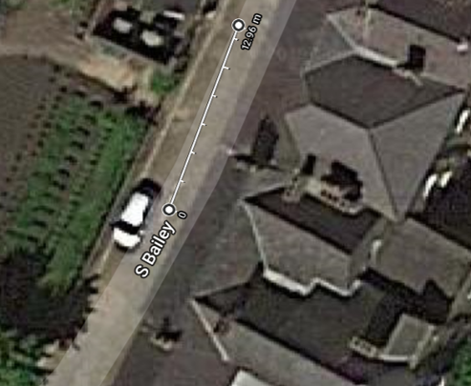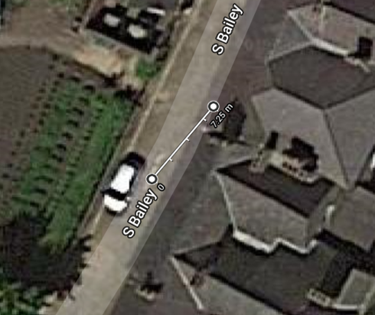

Fig 7b.

Fig 7a.

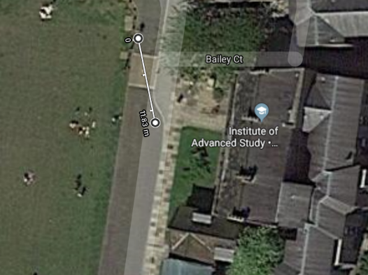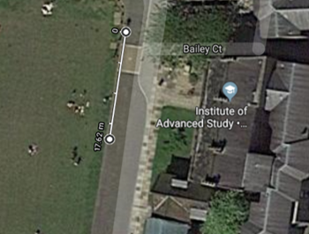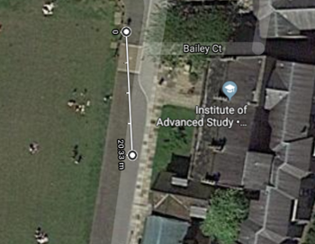Google maps data for Fig. 6c.

Fig 7c.

Fig 7e.

Fig 7d.

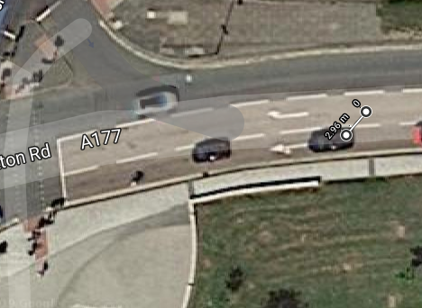Google maps data for Fig. 6e

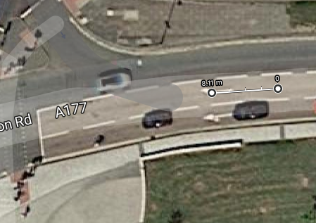

Fig 7f.

Fig 7g.

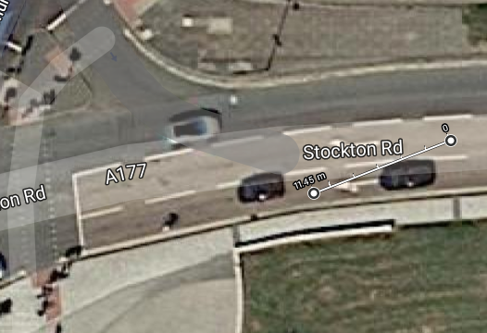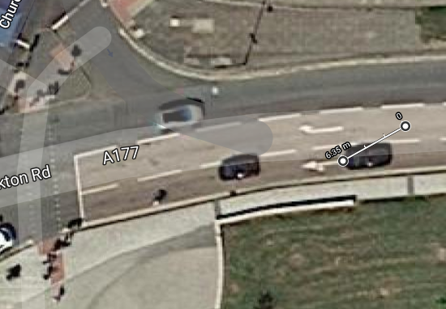

Fig 7i.

Fig 7h.

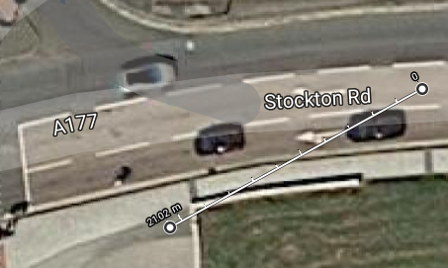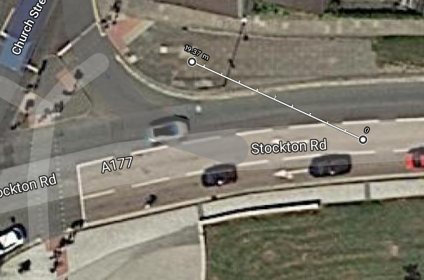

Fig 7k.

Fig 7j.

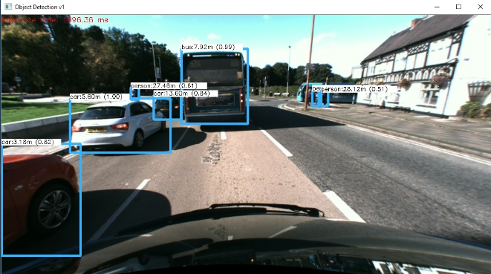

Fig 6e. (2) - Another version of Fig 6e. but instead this time the 32.18m has been removed so it is the other person’s distance is clear

Table 1a. Demonstrates the accuracy of the distances calculated in the dense stereo approach

|  |  |  |  |  |  |
| --- | --- | --- | --- | --- | --- |
| **Figure** (Dense) | **Object** | **Distance Measured** (m) | **Actual Distance** (m) | **Difference** (m) | **% Inaccuracy** |
| 6b | Van | 14.98 | 12.96 | 2.02 | +15.6 |
| 6b | Person (left) | 6.95 | 7.25 | 0.30 | -4.13 |
| 6b | Person (right) | 6.98 | 7.30 | 0.32 | -4.38 |
| 6c | Car | 12.73 | 11.83 | 0.90 | +7.61 |
| 6c | Truck | 22.42 | 20.33 | 2.09 | +10.28 |
| 6c | Person | 18.66 | 17.42 | 1.24 | +7.12 |
| 6e | Car (Red) | 3.18 | 2.96 | 0.22 | -7.43% |
| 6e | Car (White) | 5.60 | 6.35 | 0.75 | +11.8% |
| 6e | Bus | 7.92 | 8.11 | 0.19 | +2.34% |
| 6e | Car (Green) | 13.60 | 11.45 | 2.25 | -19.65% |
| 6e (2) | Person (Left) | 27.46 | 21.02 | 6.44 | +30.64% |
| 6e | Person (right) | 28.12 | 19.37 | 8.75 | +45.17% |
| **Total** |  |  |  |  | 13.86% |

**Comparison between Sparse and Dense Implementations:**

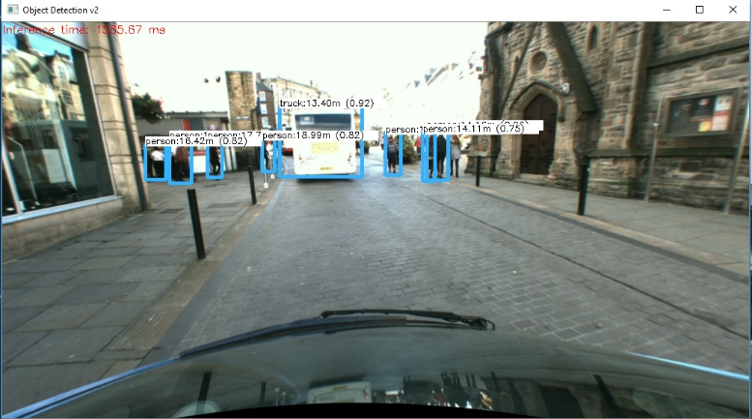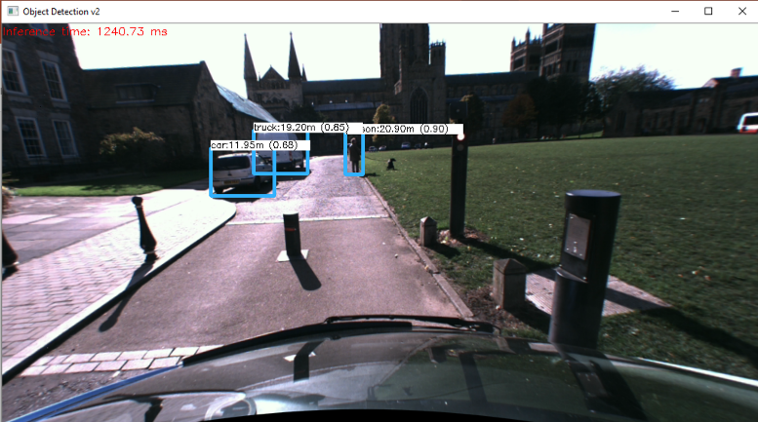The below images are the same as those in Fig. 6x, however, they have been applied to a sparse stereo algorithm rather than a dense, and the distance has been calculated simply through averaging the matched features.

Fig 8a.

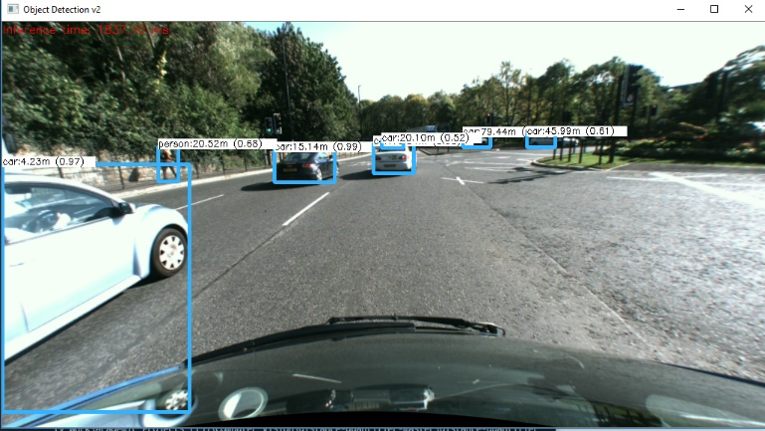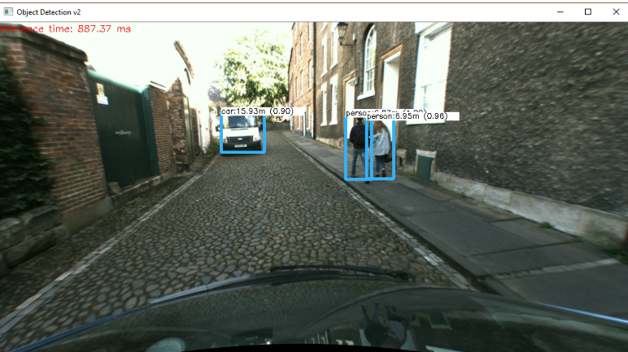

Fig 8b.

Fig 8d.

Fig 8c.

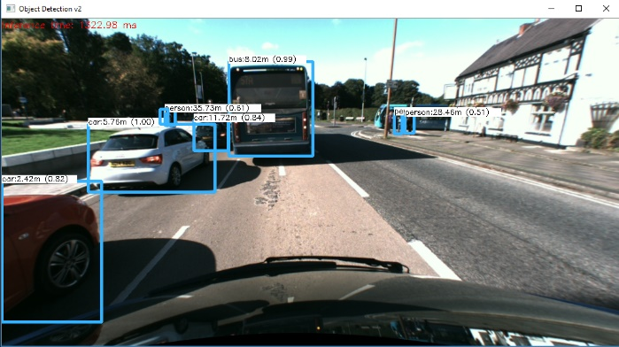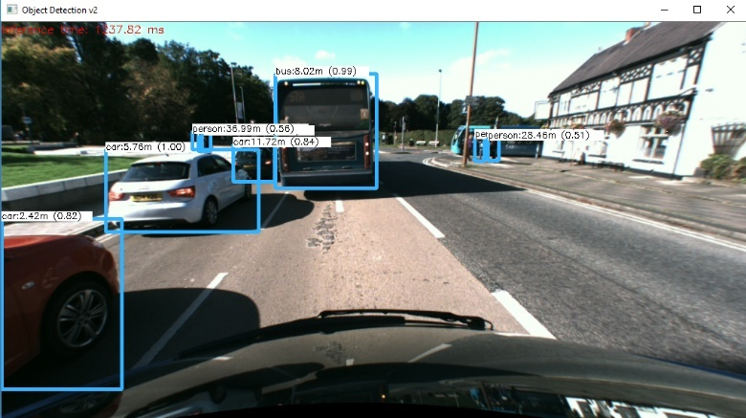

Fig 8e. (2) – Another version of Fig. 8e but instead the time 36.99m has been removed so the other person’s distance is clear

Fig 8e.

Table 2a. Demonstrates the difference in objects detected by each approach

|  |  |  |  |  |
| --- | --- | --- | --- | --- |
| **Sparse Image** | **Number of detected objects** | **Dense Image** | **Number of detected objects** | **Difference** |
| Fig 8a | 8 | Fig 6a | 8 | 0 |
| Fig 8b | 3 | Fig 6b | 3 | 0 |
| Fig 8c | 3 | Fig 6c | 3 | 0 |
| Fig 8d | 6 | Fig 6d | 6 | 0 |
| Fig 8e | 8 | Fig 6e | 8 | 0 |

Table 2b. Demonstrates the differences in distances calculated by each approach

|  |  |  |  |  |  |
| --- | --- | --- | --- | --- | --- |
| **Figure** (Dense) | **Object** | **Distance Measured** (m) | **Actual Distance** (m) | **Difference** (m) | **% Inaccuracy** |
| 8b | Van | 15.93 | 12.96 | 2.97 | 22.92% |
| 8b | Person (left) | 6.97 | 7.25 | 0.28 | 3.86% |
| 8b | Person (right) | 6.95 | 7.30 | 0.35 | 4.79% |
| 8c | Car | 11.95 | 11.83 | 0.12 | 1.01% |
| 8c | Truck | 19.20 | 20.33 | 1.13 | 5.56% |
| 8c | Person | 20.90 | 17.42 | 3.48 | 20.00% |
| 8e | Car (Red) | 2.42 | 2.96 | 0.54 | 18.24 |
| 8e | Car (White) | 5.76 | 6.35 | 0.59 | 9.28 |
| 8e | Bus | 8.02 | 8.11 | 0.09 | 1.11 |
| 8e | Car (Green) | 11.72 | 11.45 | 0.27 | 2.36 |
| 8e | Person (Left) | 35.73 | 21.02 | 14.71 | 69.98 |
| 8e | Person (right) | 28.48 | 19.37 | 9.06 | 46.77 |
| **Total** |  |  |  |  | 17.89% |

**Conclusion**:

**Fig 1a.**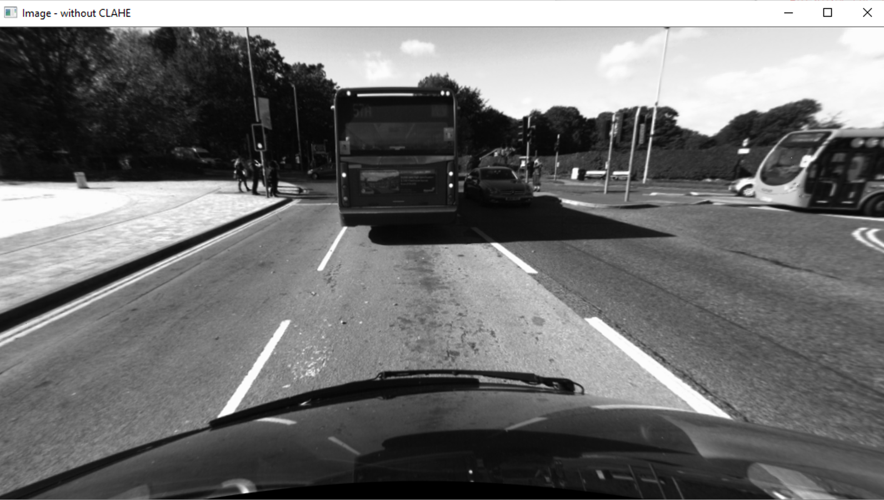

**Fig 1b**

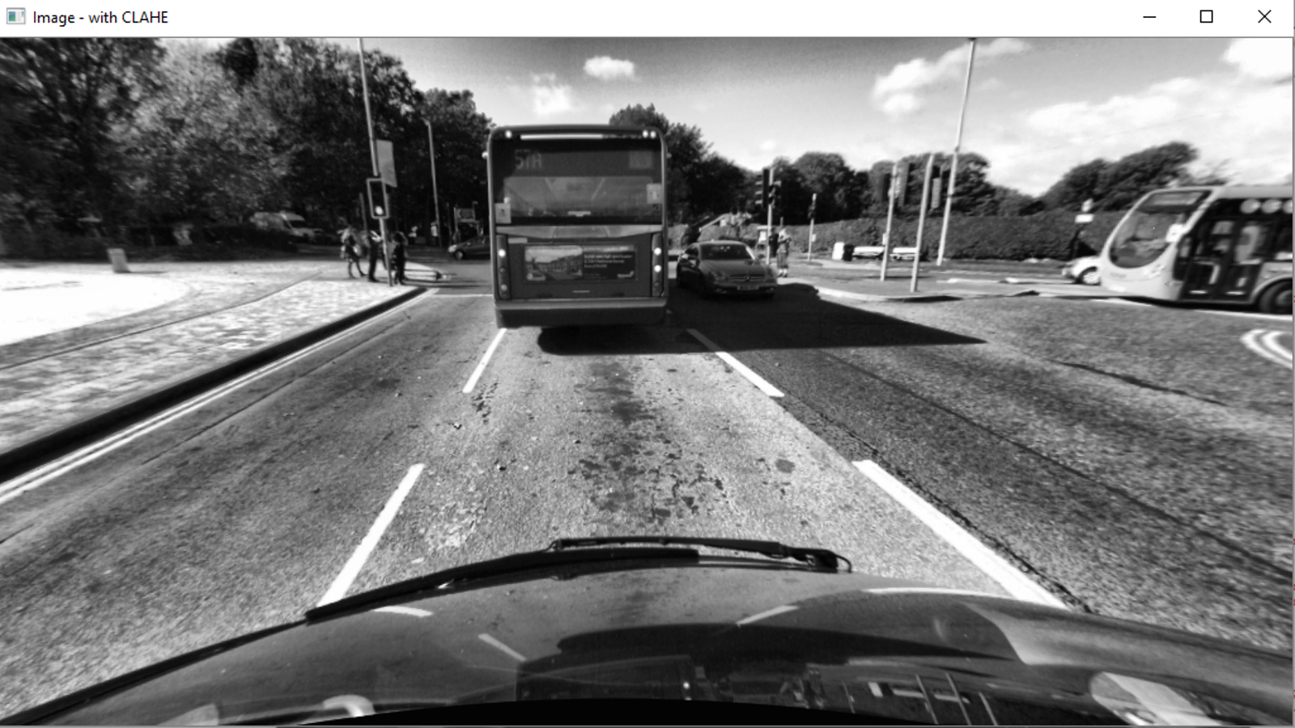

**Fig 2a**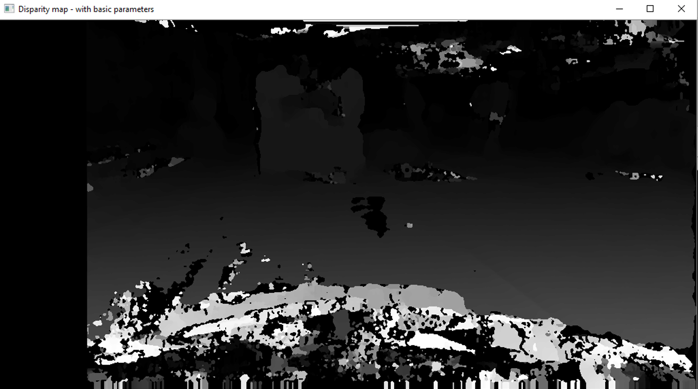

**Fig 2b.**

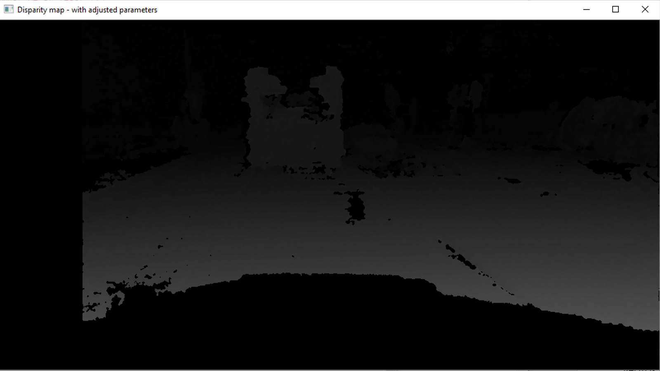

**Fig 3a.**

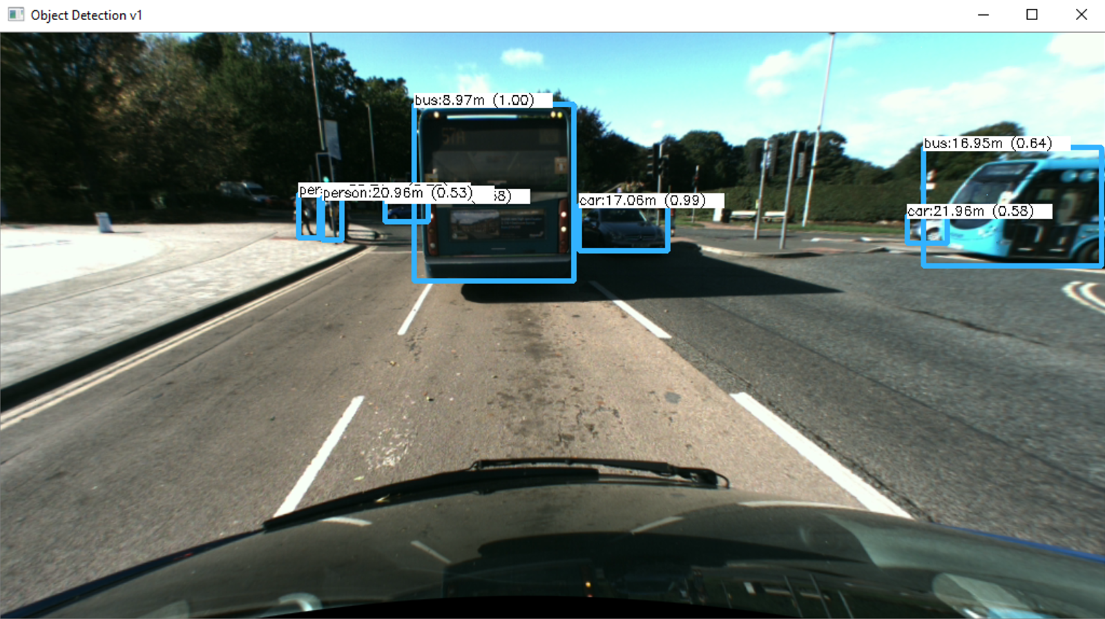

**Fig 3b.**

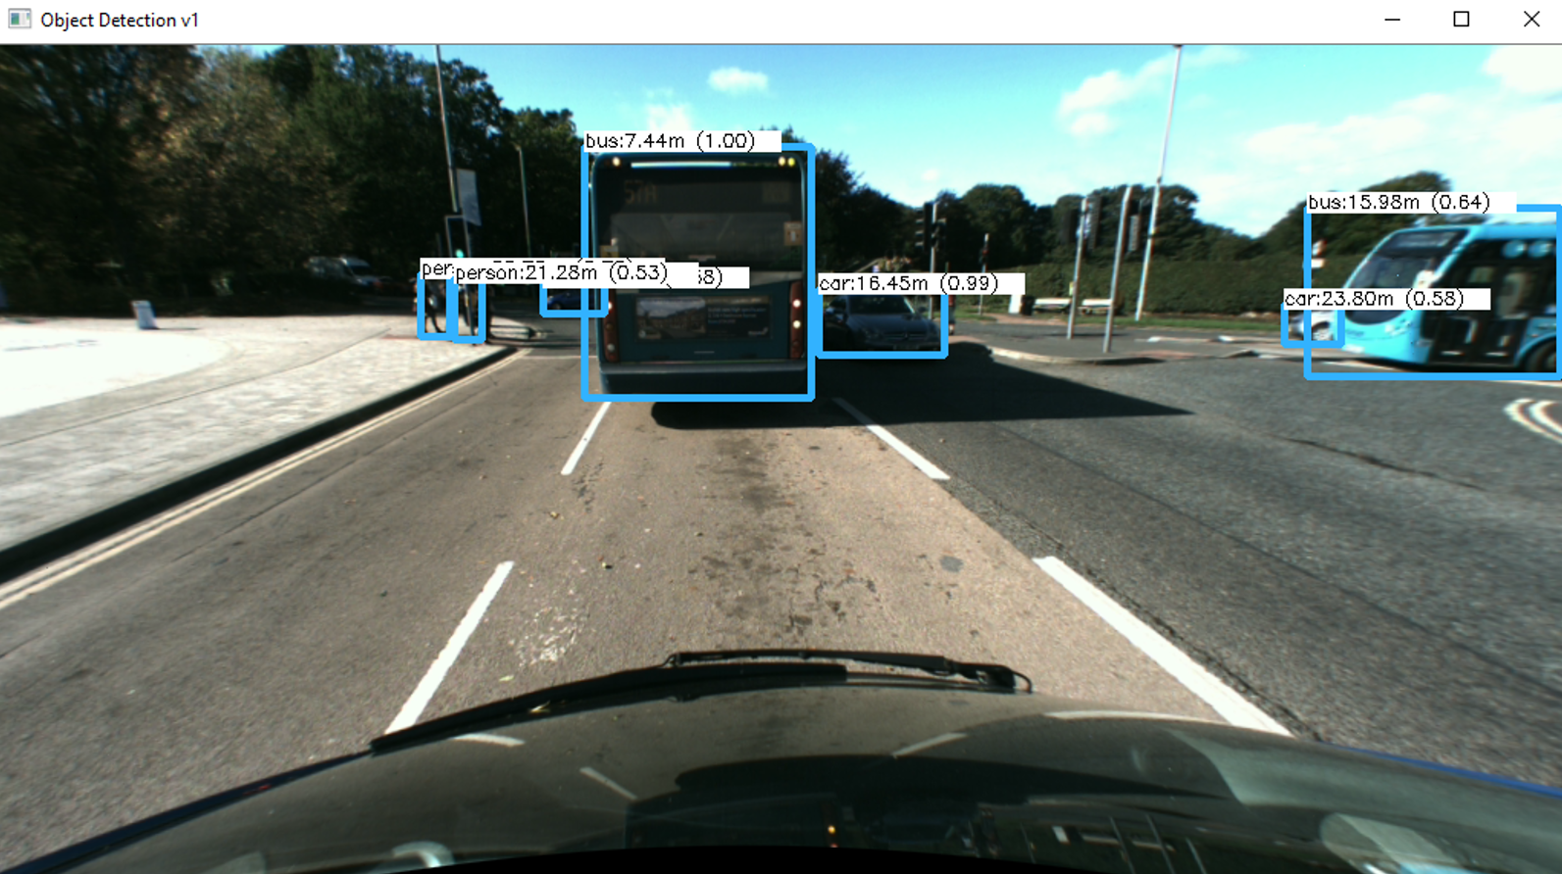

**Fig 3c.**

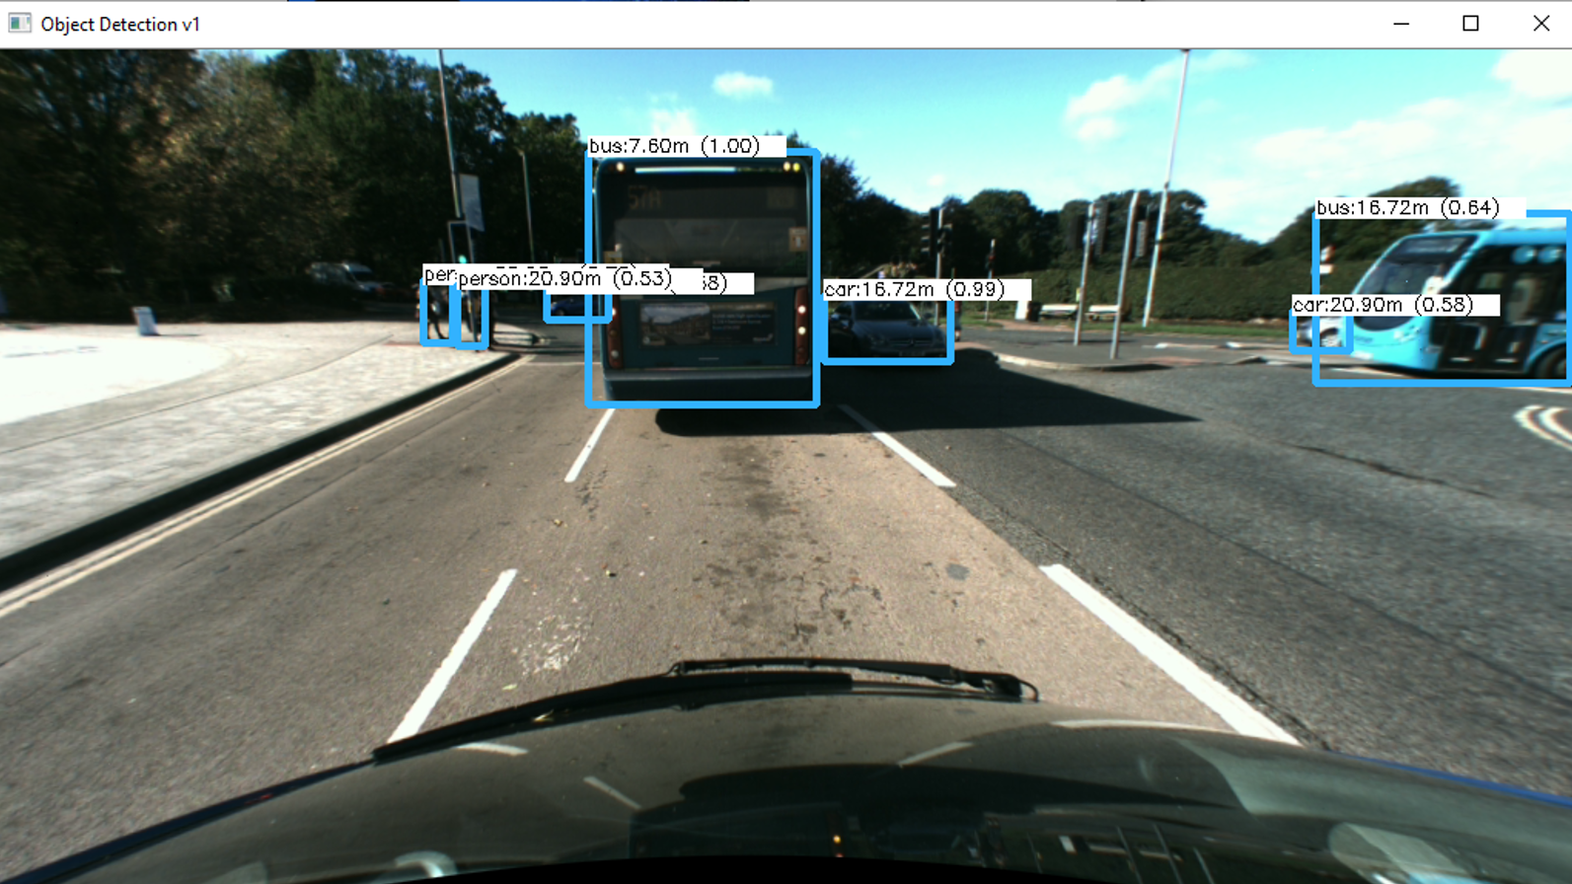

**Fig 3d.**

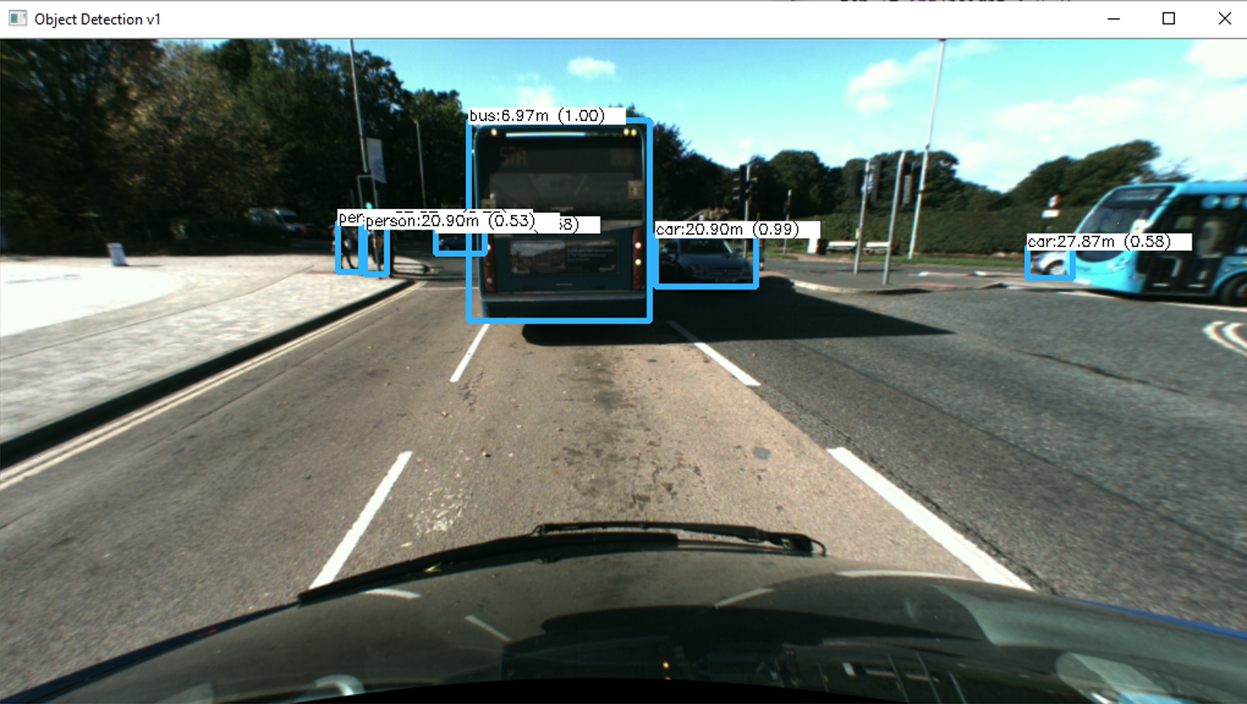

**Fig 4a.**

**Fig 4b.**

**Fig 4**

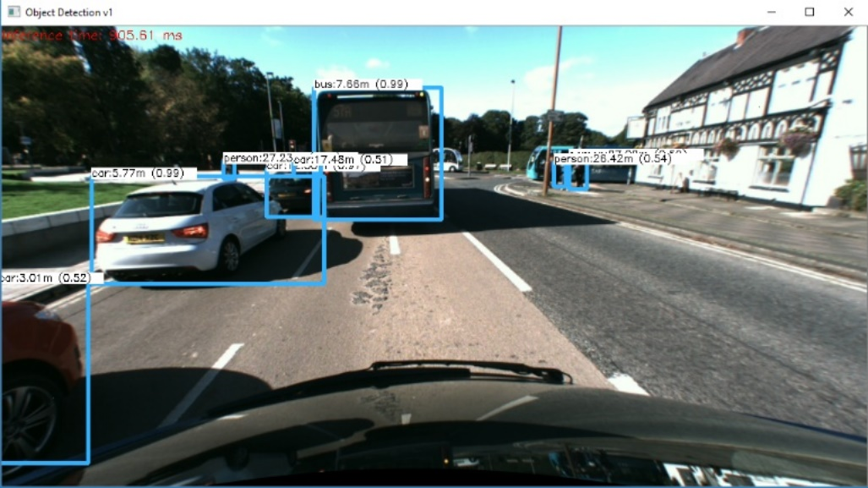**Fig 4d**

**Fig 5a**



**Fig 5b**

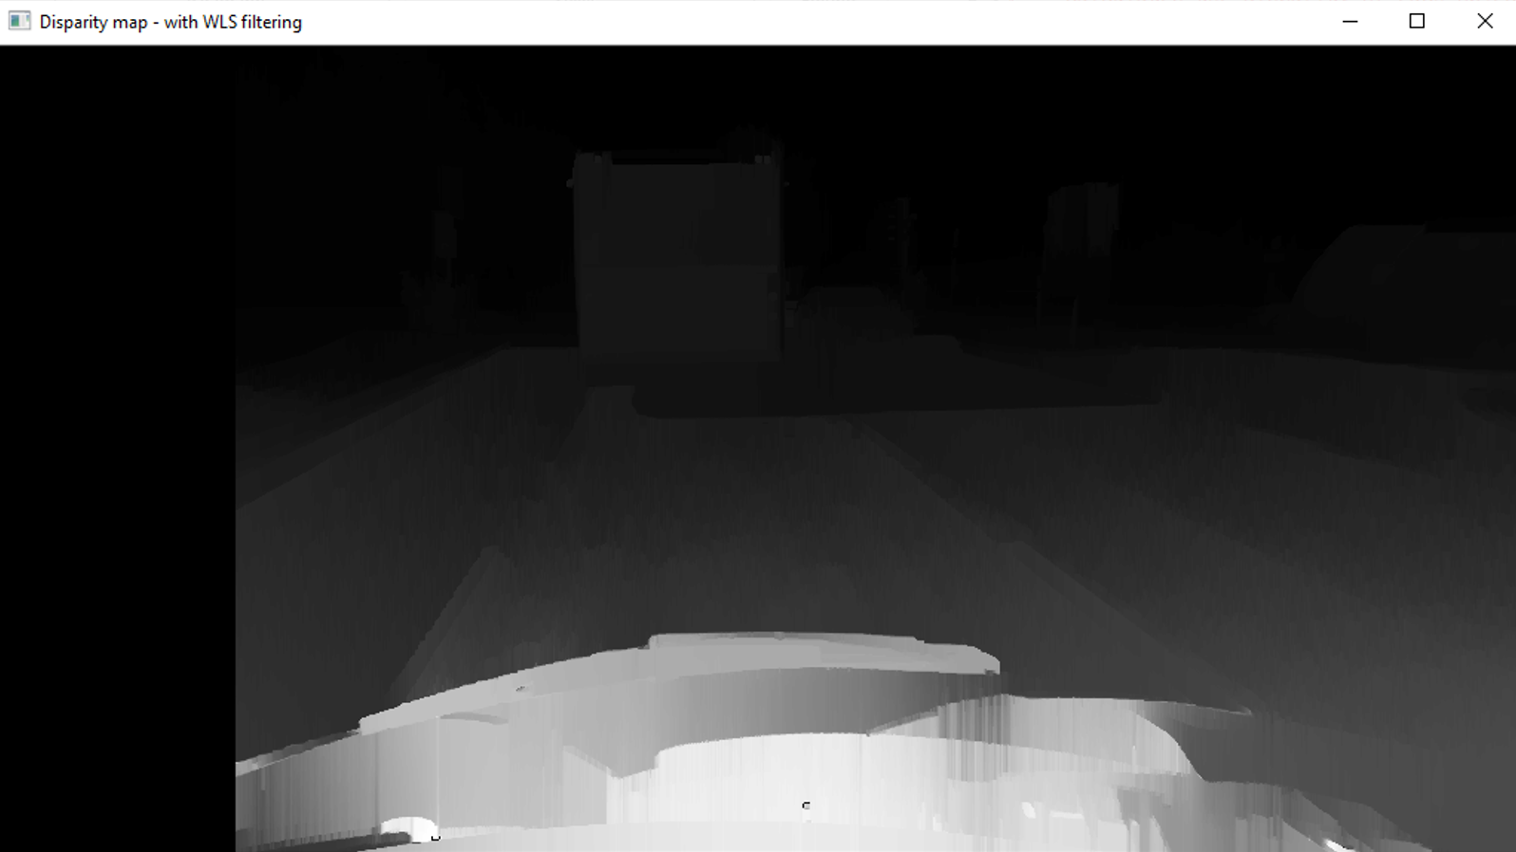

**Fig. 6a**

**Fig. 6b**

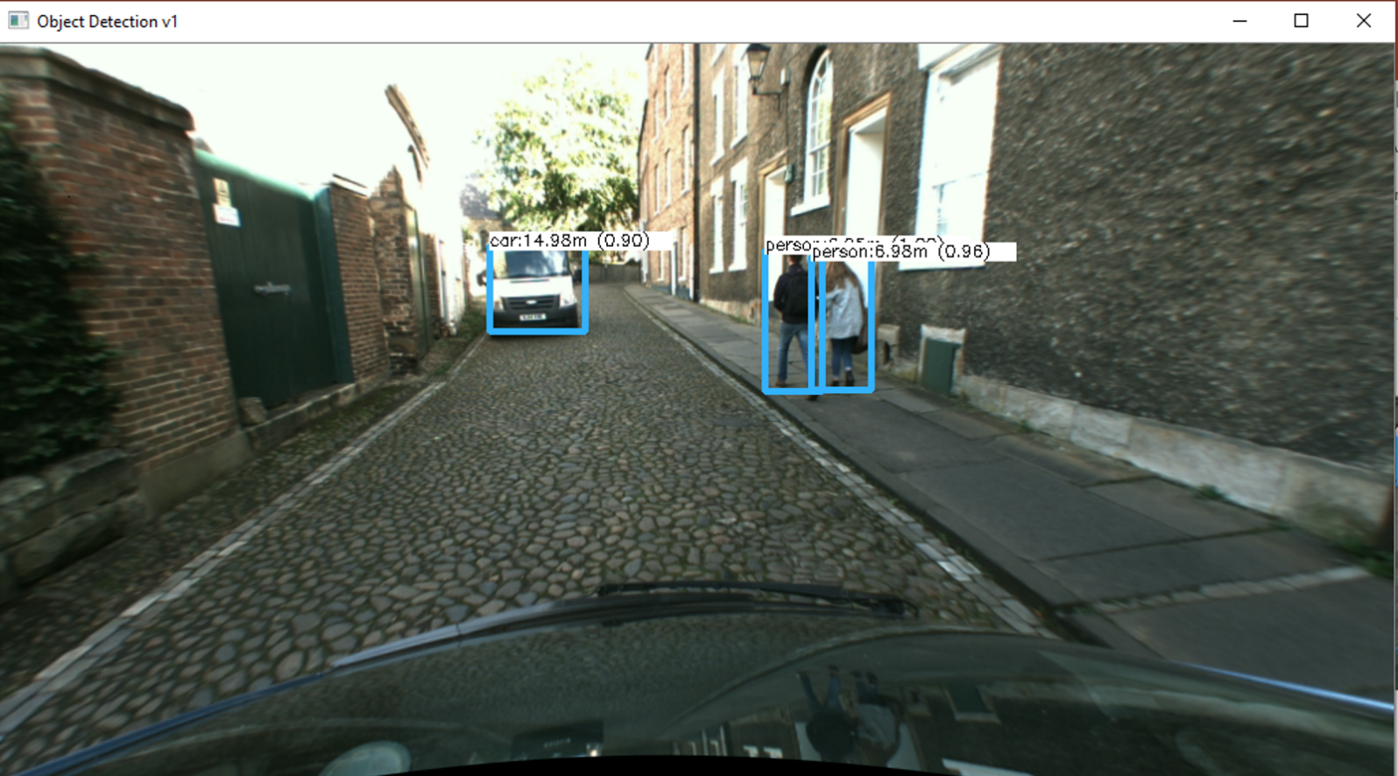

**Fig. 6c**

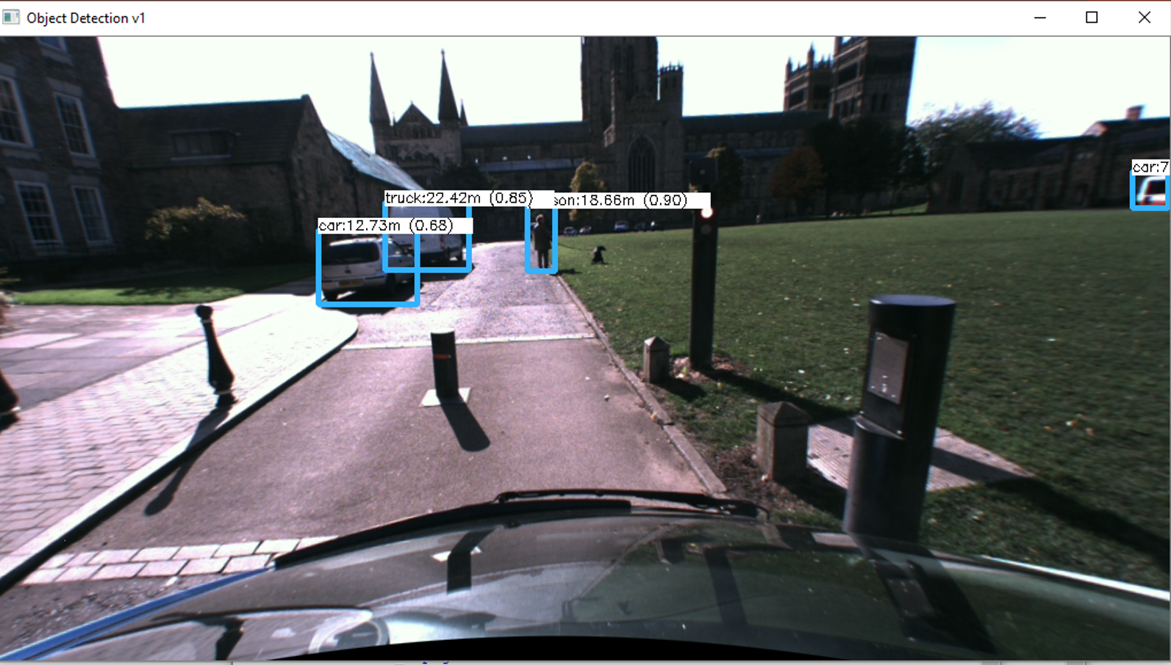

**Fig. 6d**



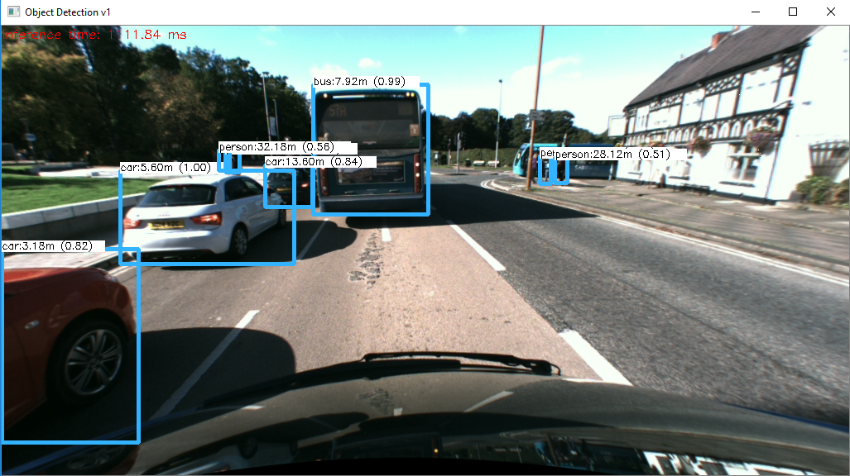**Fig. 6e**

**Fig 7a**



**Fig 7b**



**Fig 7c.**

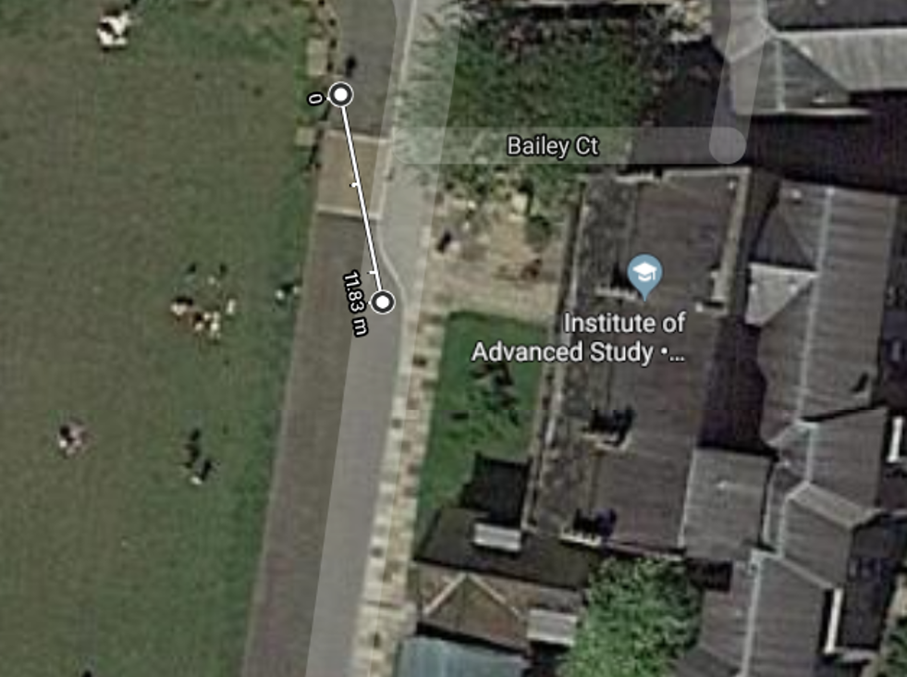

**Fig 7d**

**Fig 7e.**



**Fig 7f.**

**Fig 7g.**



**Fig 7h.**



**Fig. 7i**

**Fig 7j.**

**4**

**Fig. 7k**

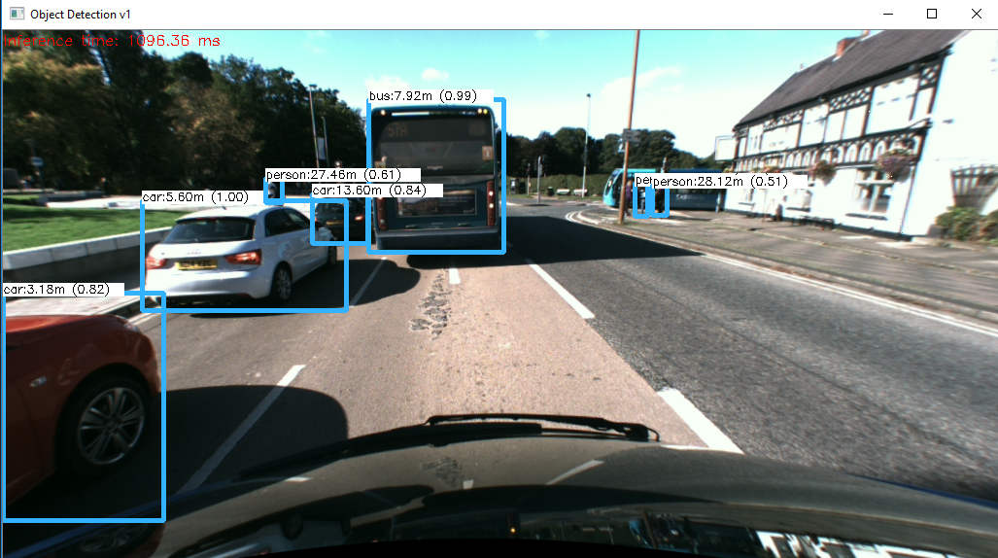**Fig. 6e (2)**

**Fig 8a.**

**Fig 8b.**

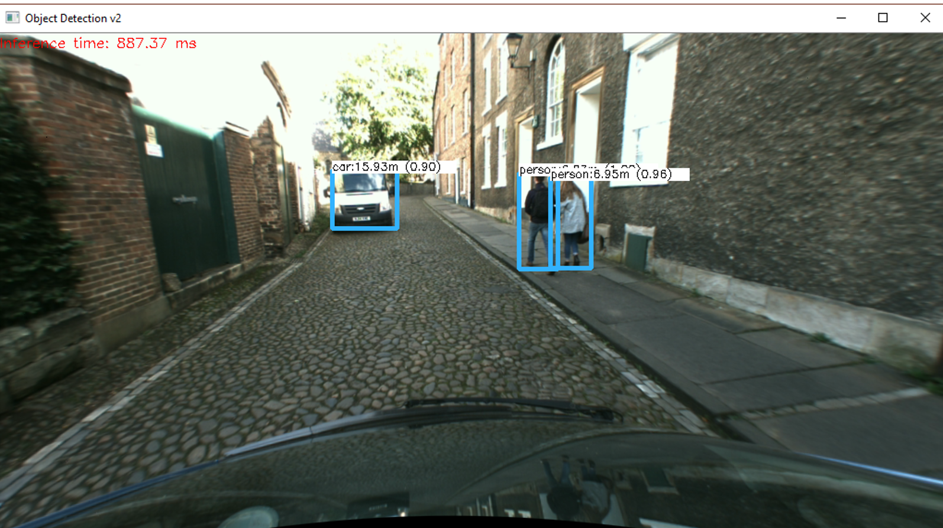

**Fig 8c.**

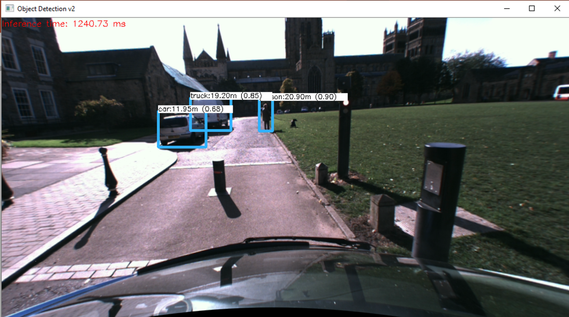

**Fig 8d.**

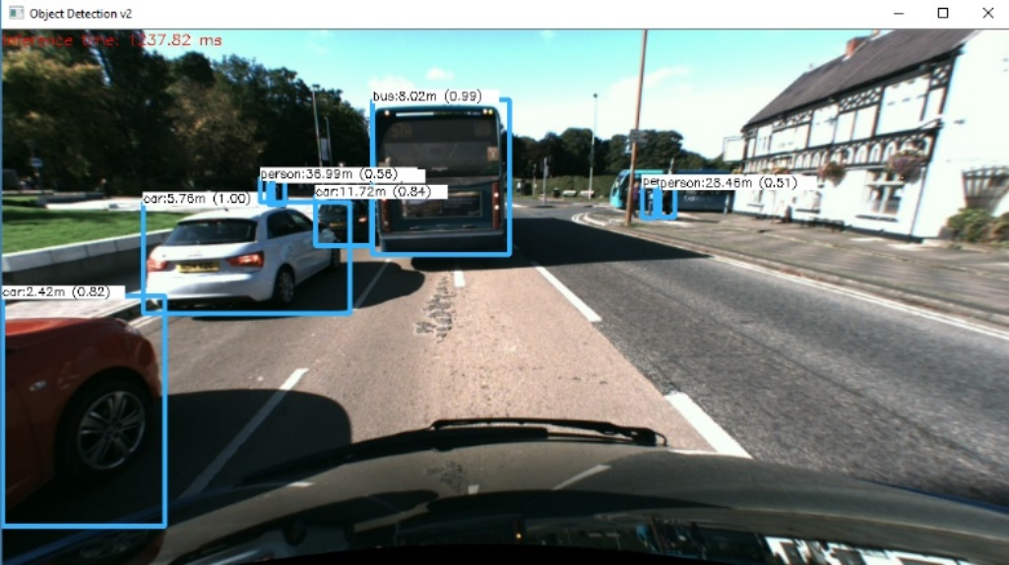**Fig 8e**

**Fig 8e. (2)**

